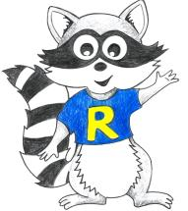
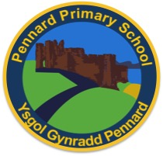
Key Stage 2 Home Learning
Week Beginning: 22.06.20
ABACUS READING TEXT: I have also allocated ‘Technology’ on Abacus.
Year 6
Weekly Topics
- Maths: Circles and rotational symmetry
- Literacy: Persuasive writing
- Inquiry: One activity to last the whole week: Being ‘social media’ safe.
Monday | - Maths: Targ Maths: My maths: Circles lesson  - Literacy Writing: Persuasive writing: Spies  - Back to school reflection  - Active: Daily Mile Joe Wicks
Tuesday | - Maths: Targ maths: My maths: Circles homework  - Literacy Writing: Persuasive writing: Spies  - Active: Daily Mile Design a circuit in your garden – how quickly can you do it?
Wednesday | - Maths: Targ Maths: My maths: Rotational Symmetry homework  - Literacy Writing: Persuasive writing: Spies  - Active: Daily Mile Create a dance routine, record it and send it to us!
Thursday | - Maths: Targ maths: My maths: Rotational Symmetry lesson  - Literacy Spelling: ‘Pro and Sus’ (See Powerpoint)  - Active: Daily Mile How many laps of your garden can you complete in 20 minutes?
Friday | - Maths: Targ Maths: ‘Obstacle Course Catastrophe’ – shared in Hwb file - answers available too, no peeking!!  - Literacy Comprehension questions: ‘The Nowhere Emporium’ (See Powerpoint)  - Dancy Mat Typing: https://www.bbc.co.uk/bitesize/topics/zf2f9j6/articles/z3c6tfr  - Active: Daily Mile Joe Wicks fancy dress!
Accessing Bug Club
