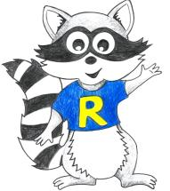
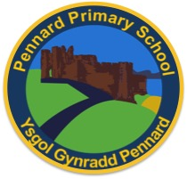
Key Stage 2 Home Learning
Week Beginning: 15.06.20
ABACUS READING TEXT: I have also allocated ‘Petronas’ on Abacus.
Year 6
Weekly Topics
- Maths: Triangles, lines and quadrilaterals
- Literacy: Poetry
- Inquiry: One activity to last the whole week: How to be the best version of myself?
Monday | - Maths: Targ Maths: My maths: Properties of Triangles lesson  - Literacy Writing: Poetry: Rain  - Active: Daily Mile Joe Wicks
Tuesday | - Maths: Targ maths: My maths: Properties of Triangles homework  - Literacy Writing: Poetry: The magical door  - Active: Daily Mile Design a circuit in your garden – how quickly can you do it?
Wednesday | - Maths: Targ Maths: My maths: Lines and quadrilaterals homework  - Literacy Writing: Poetry: The magical door  - Active: Daily Mile Create a dance routine, record it and send it to us!
Thursday | - Maths: Targ maths: My maths: Lines and quadrilaterals lesson  - Literacy Spelling: ‘Ch Words’ (See Powerpoint)  - Active: Daily Mile How many laps of your garden can you complete in 20 minutes?
Friday | - Maths: Targ Maths: ‘The Mystery of the Missing Pirate Treasure’ – shared in Hwb file - answers available too, no peeking!!  - Literacy Comprehension questions: ‘Children at Work’ (See Powerpoint)  - Dancy Mat Typing: https://www.bbc.co.uk/bitesize/topics/zf2f9j6/articles/z3c6tfr  - Active: Daily Mile Joe Wicks fancy dress!
Accessing Bug Club
