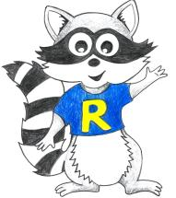
Key Stage 2 Home Learning
Week Beginning: 15.06.20
ABACUS READING TEXT:. I have allocated How to be a pop star by Louise Spilsbury on Abacus. Please read as much as possible. Although we are doing mymaths this week I have still allocated some more maths games on abacus for Friday. Pob lwc!
Year 5
Weekly Topics
- Maths: Place value
- Literacy: Poetry
- Inquiry: One activity to last the whole week: How can you get closer to the best version of yourself?
Monday | - Maths: MyMaths- Place value  - Literacy Writing: Poetry  - Active: 100 star jumps
Tuesday | - Maths: MyMaths Place value  - Literacy Writing: Poetry  - Active: 20 burpees
Wednesday | - Maths: MyMaths Place value  - Literacy Writing: Poetry  - Active: 50 squats
Thursday | - Maths: MyMaths Place value  - Literacy Spelling: Words borrowed from other languages  - Active: 50 lunges
Friday | - Maths: Abacus games- place value  - Literacy Comprehension questions: Language and meaning  - Dancy Mat Typing: https://www.bbc.co.uk/bitesize/topics/zf2f9j6/articles/z3c6tfr  - Active: 45 second plank
Accessing Bug Club
