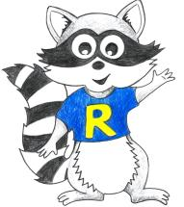
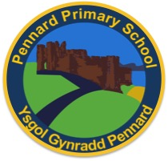
Key Stage 2 Home Learning
Week Beginning: 13.07.20
ABACUS:. Finish off Abacus Reading, spelling games and Maths games. Have a great summer!
Year 5
Weekly Topics
Maths: Perimeter, Area & Volume
myMaths:
Introducing Area, Introducing perimeter, Perimeter, Area of rectangles, Volume and capacity
Literacy: Grammar/Spelling/Comprehension
Monday | - Maths: Target Maths- Area & Perimeter  - Literacy Writing: Spellings- Unstressed vowels  - Active: Daily mile
Tuesday | - Maths: Target Maths- Area  - Literacy Writing: Comprehension (myths)  - Active: Daily mile
Wednesday | - Maths: Targ Maths- Volume  - Literacy Writing: Grammar (Reported speech)  - Active: Daily mile
Thursday | Maths: MyMaths Introducing Area, Introducing perimeter, Perimeter, Area of rectangles, Volume and capacity  - Literacy Spelling: Kahoot Games  - Active: Daily mile
Friday | - Maths: Mymaths  Introducing Area, Introducing perimeter, Perimeter, Area of rectangles, Volume and capacity  Abacus games- Finish off Abacus Reading, spelling games and Maths games. Have a great summer!

